**IAM Role**

Create windows 2012 Ec2 Instance

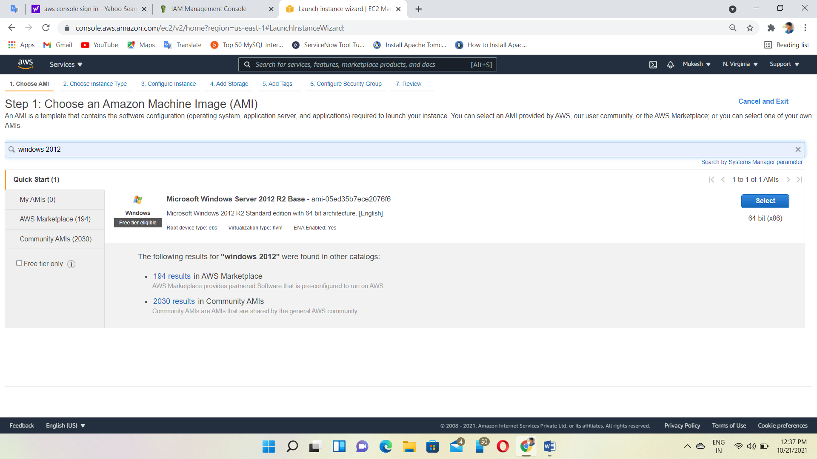

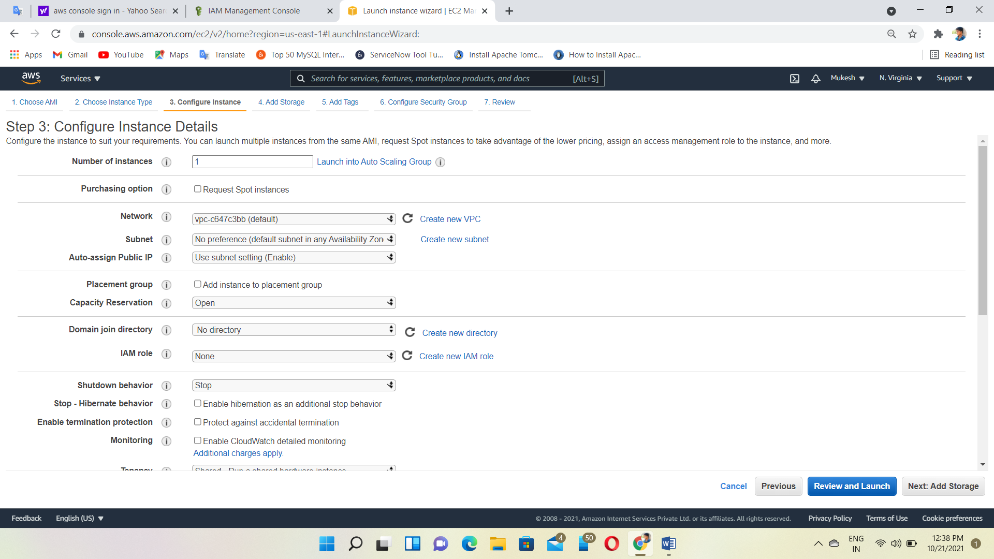

Allow all traffic

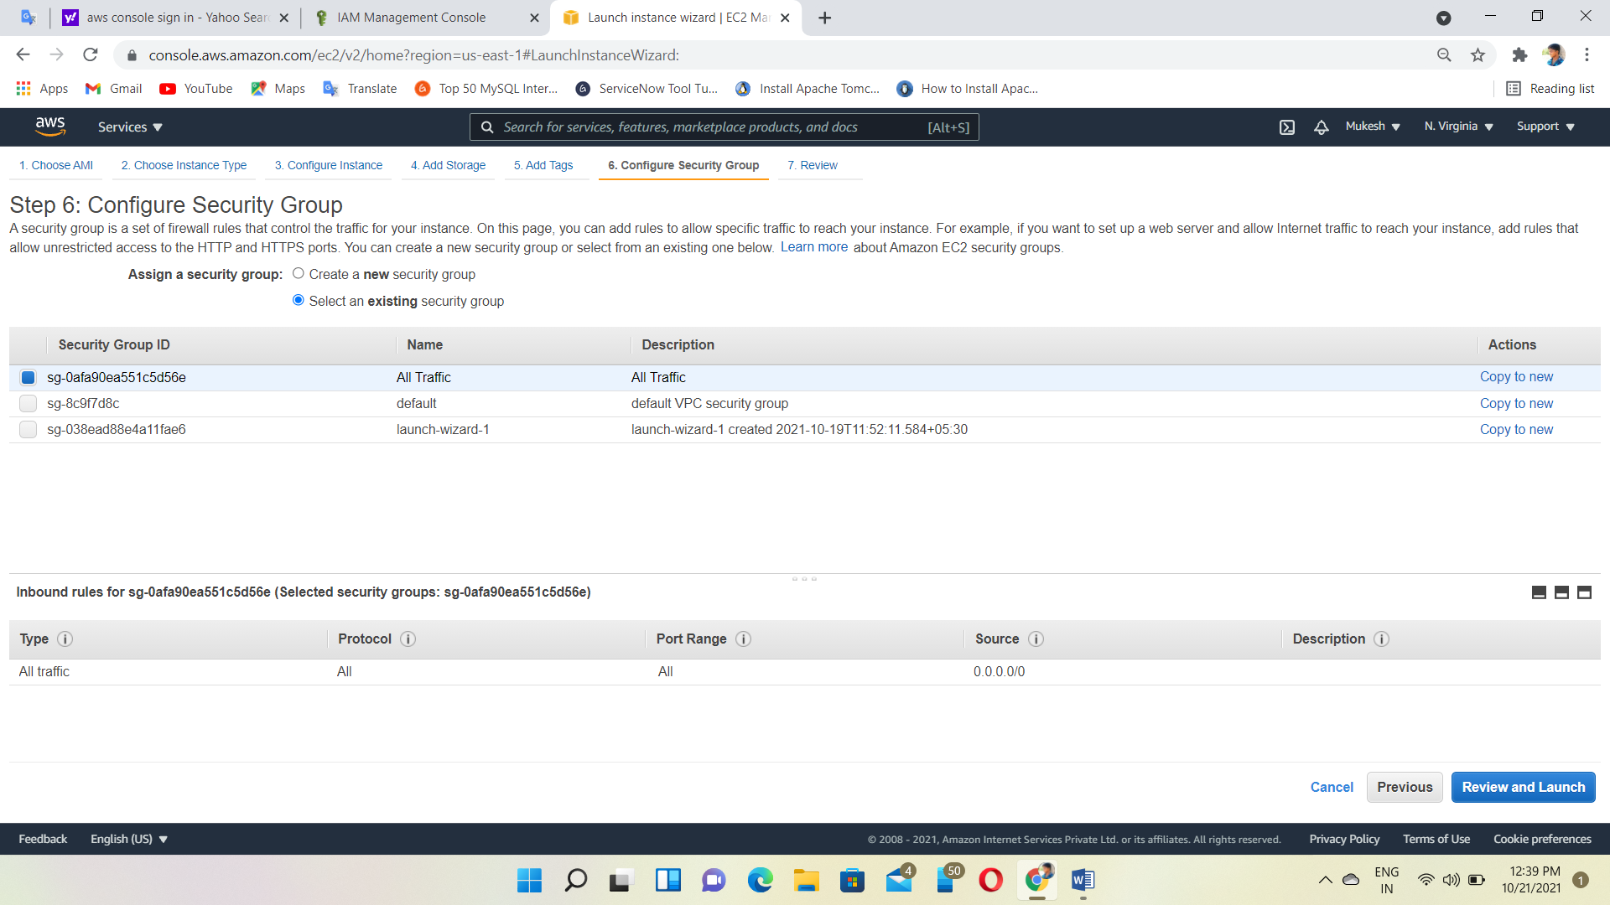

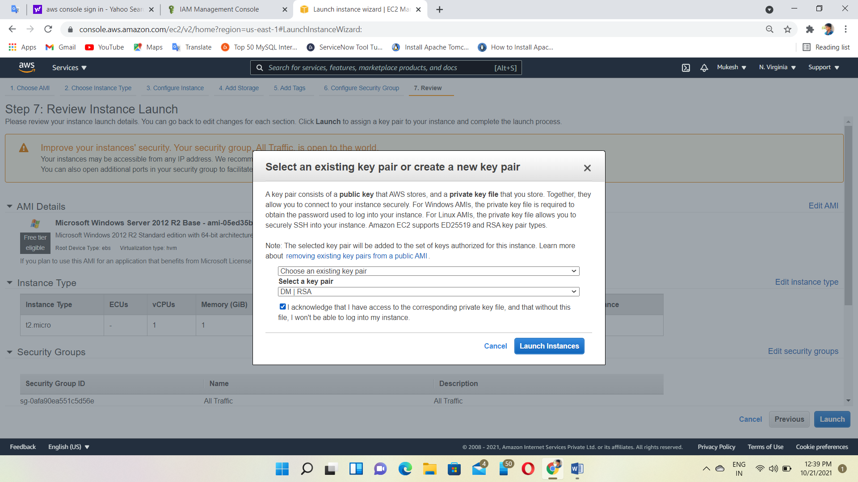

Login to the Instance

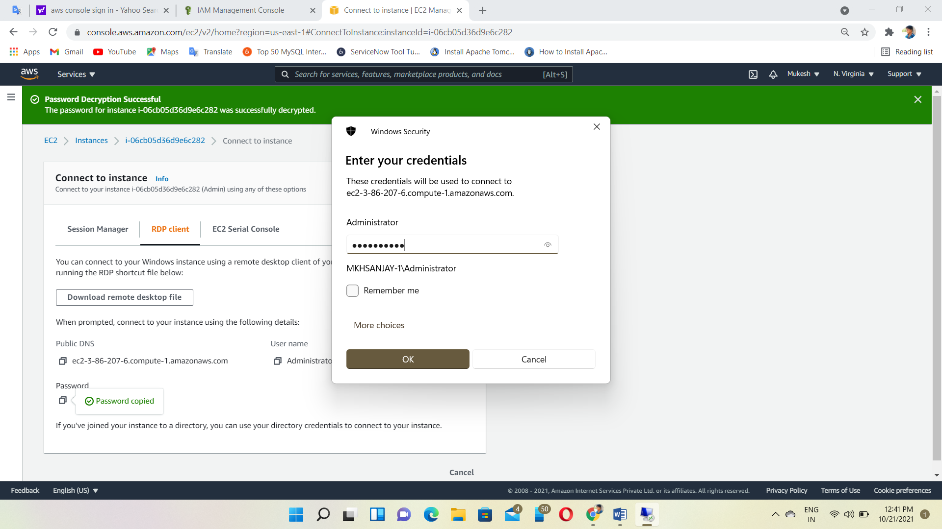

Open PowerShell ISE and check the Instance status🡪get-ec2instancestatus but, error shown

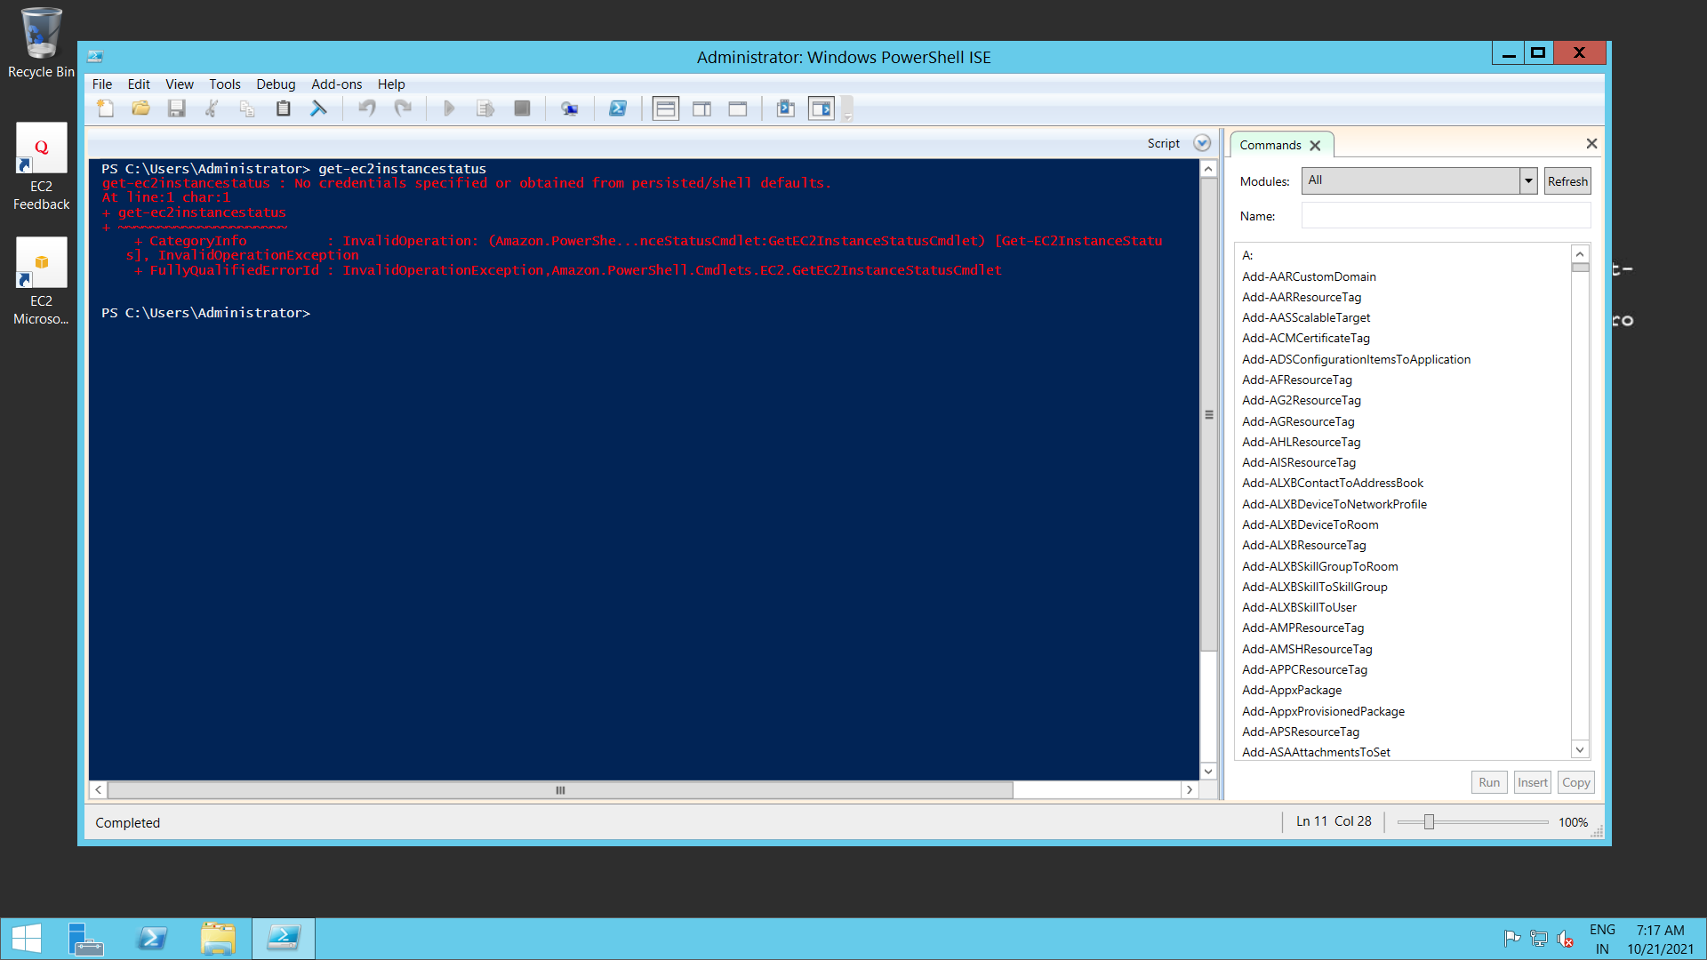

So, we create IAM Role

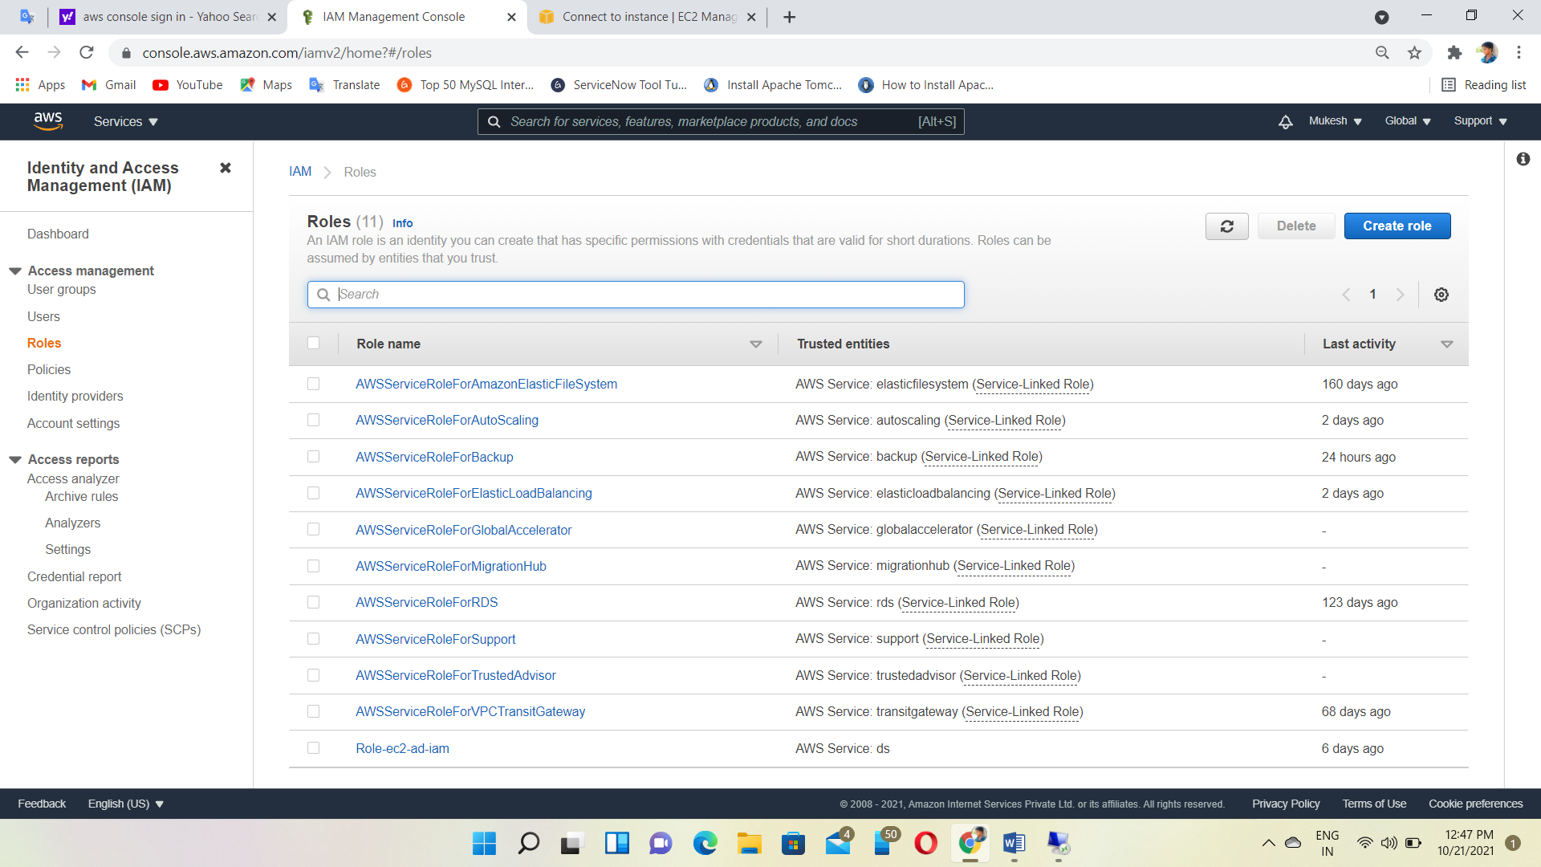

Select type of trusted entity AWS services (EC2)

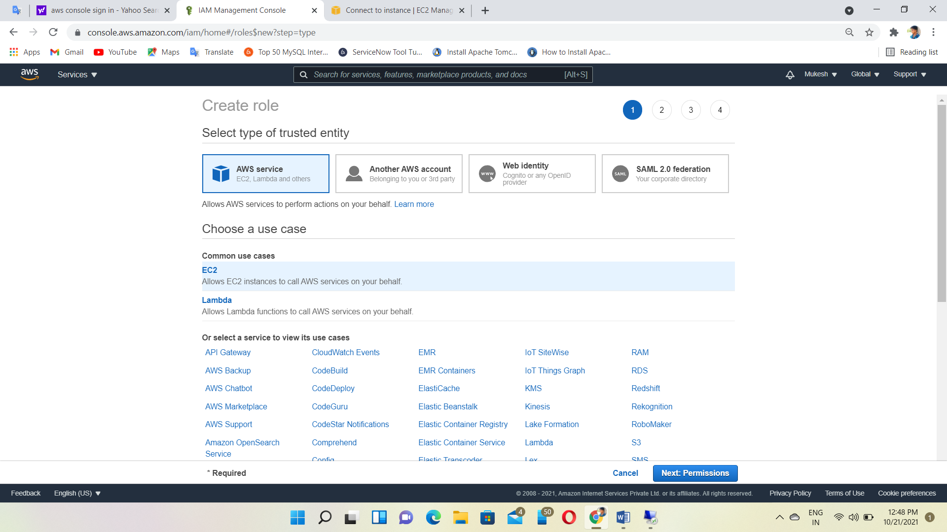

Create Policy for Role (EC2 read only access)

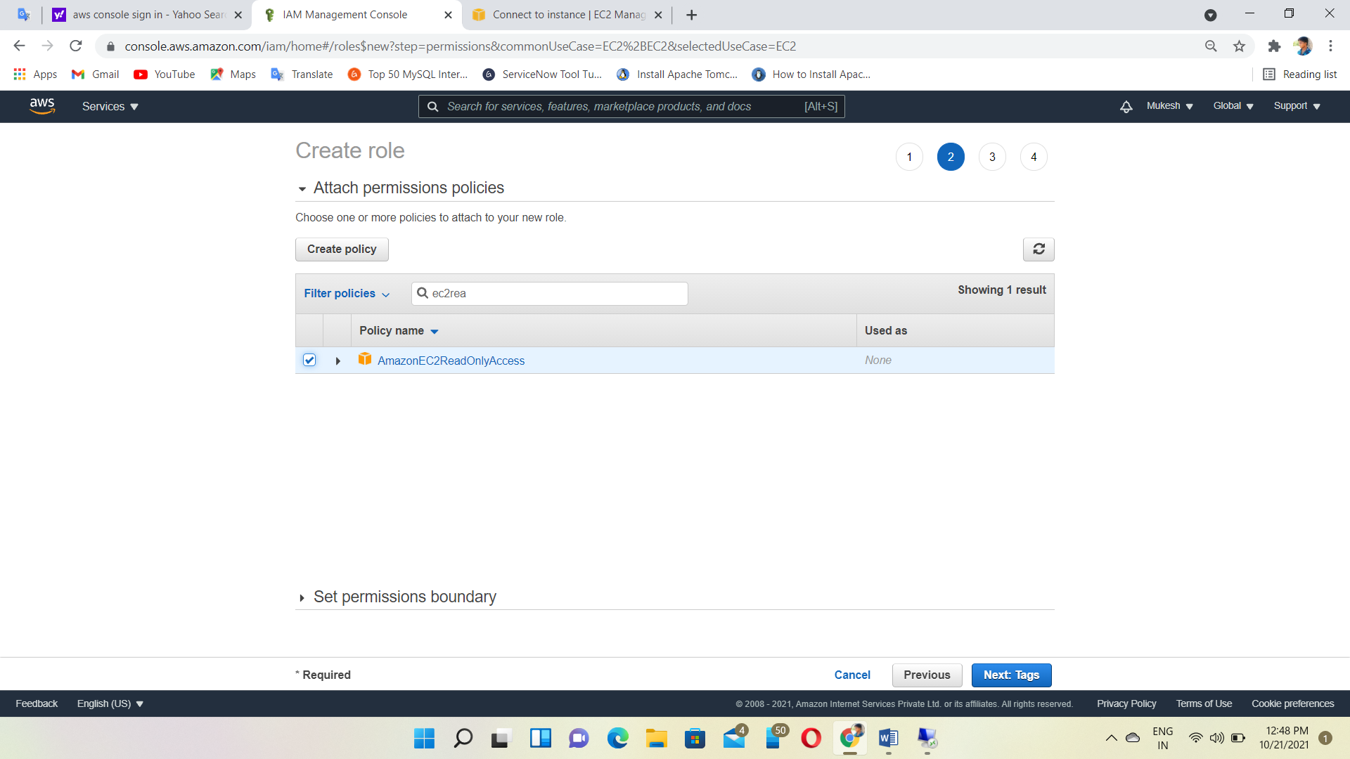

Role Created

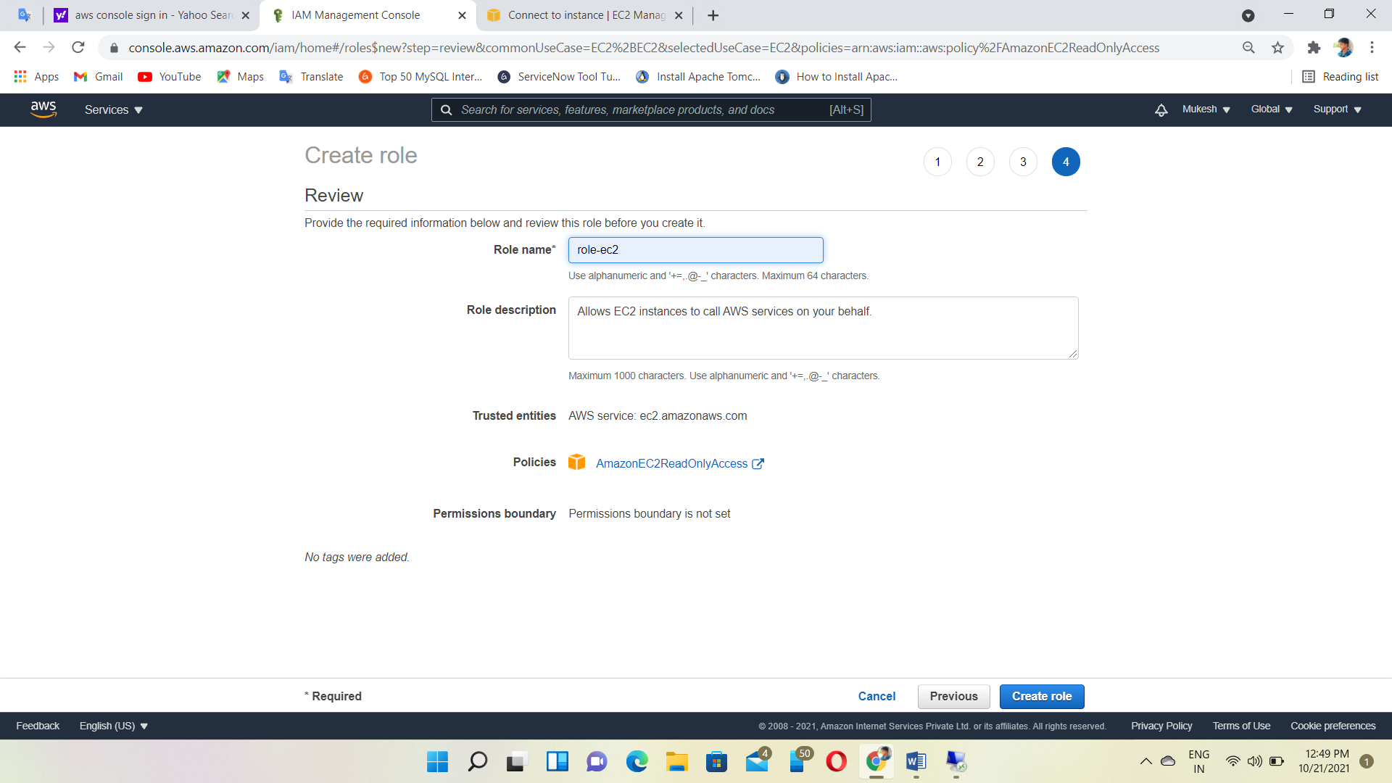

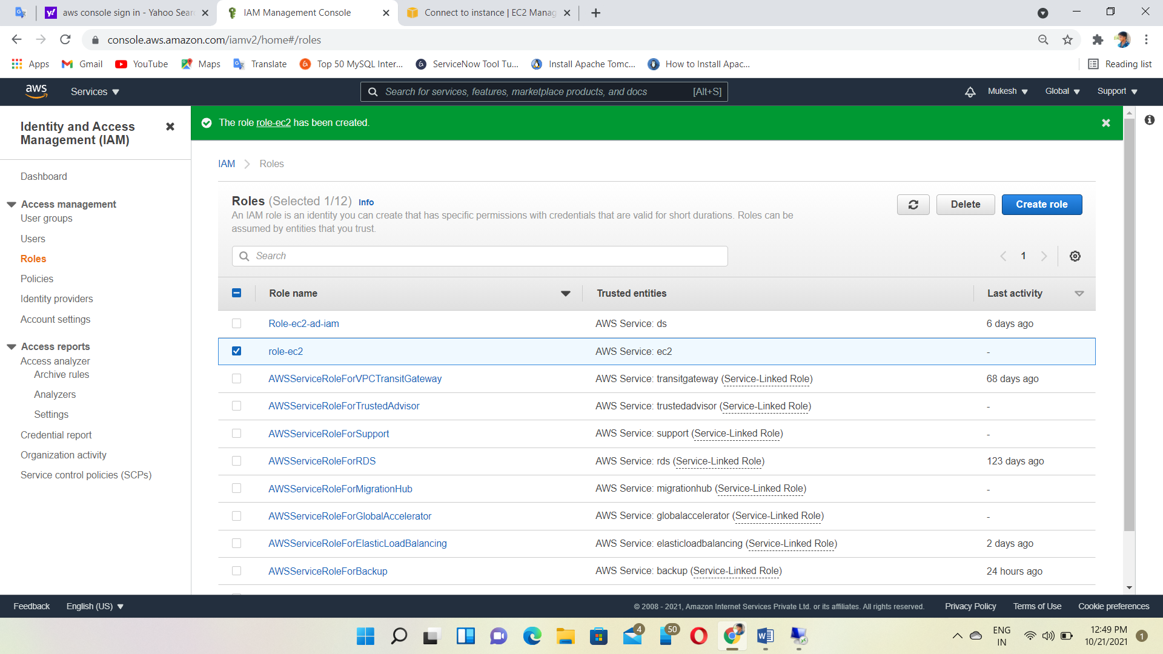

Attaching instance to IAM Role

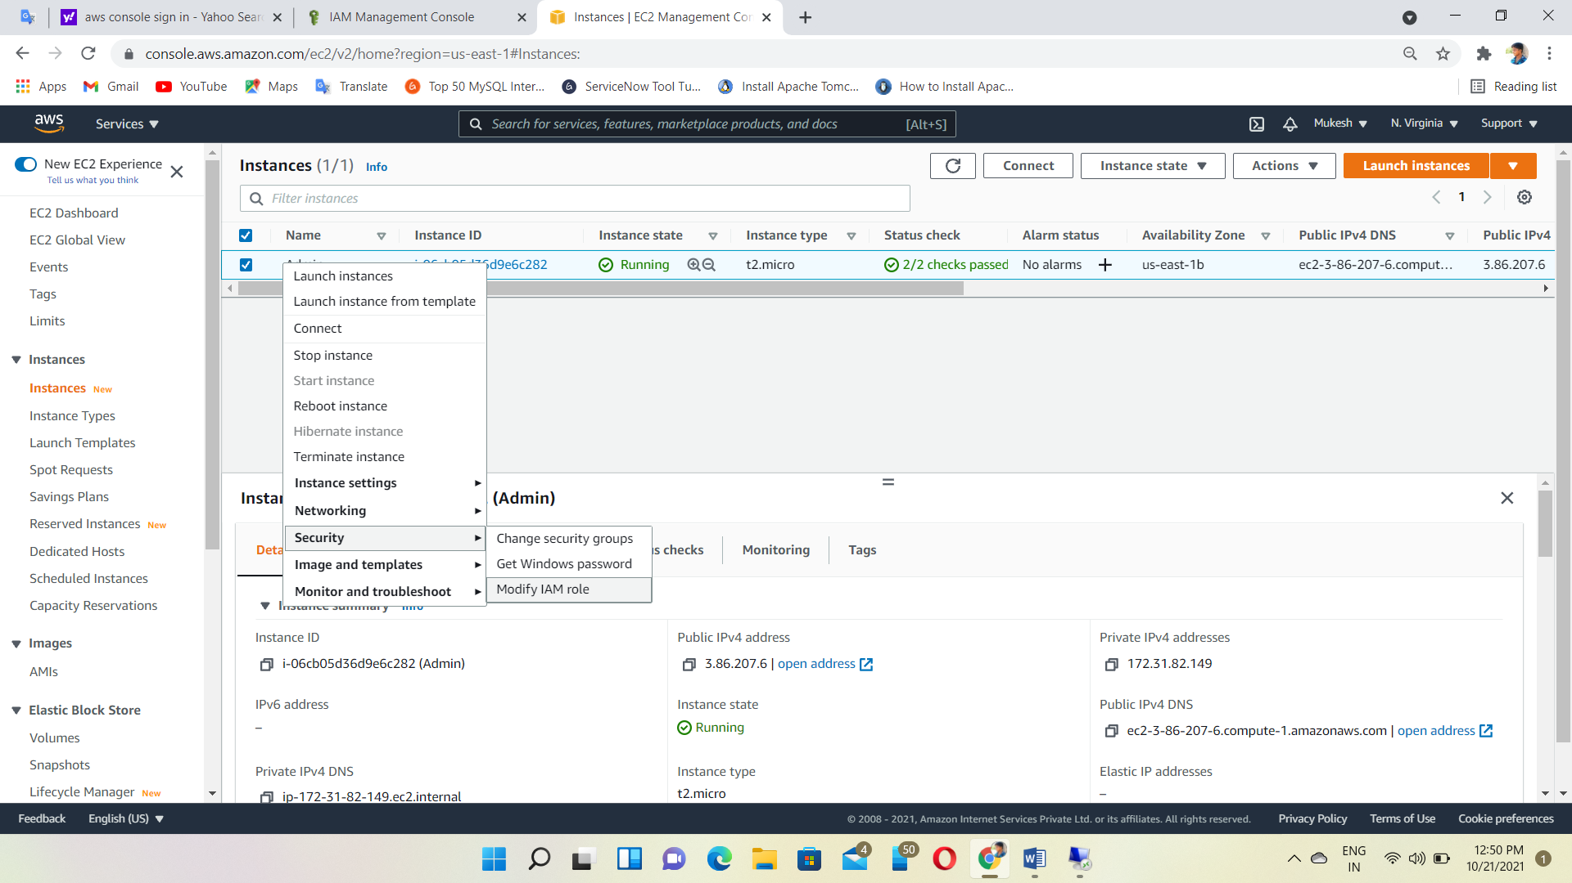

Modify IAM Role

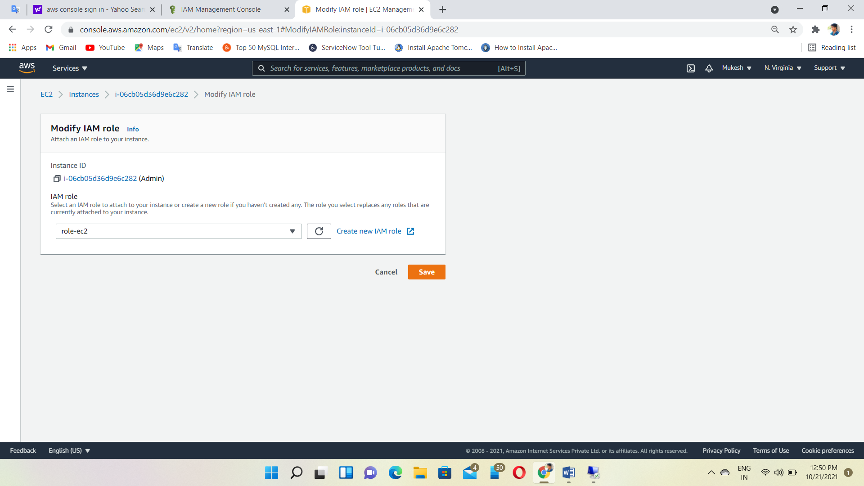

Open PowerShell ISE in windows instance and give command get-ec2instancestatus and instance details are shown

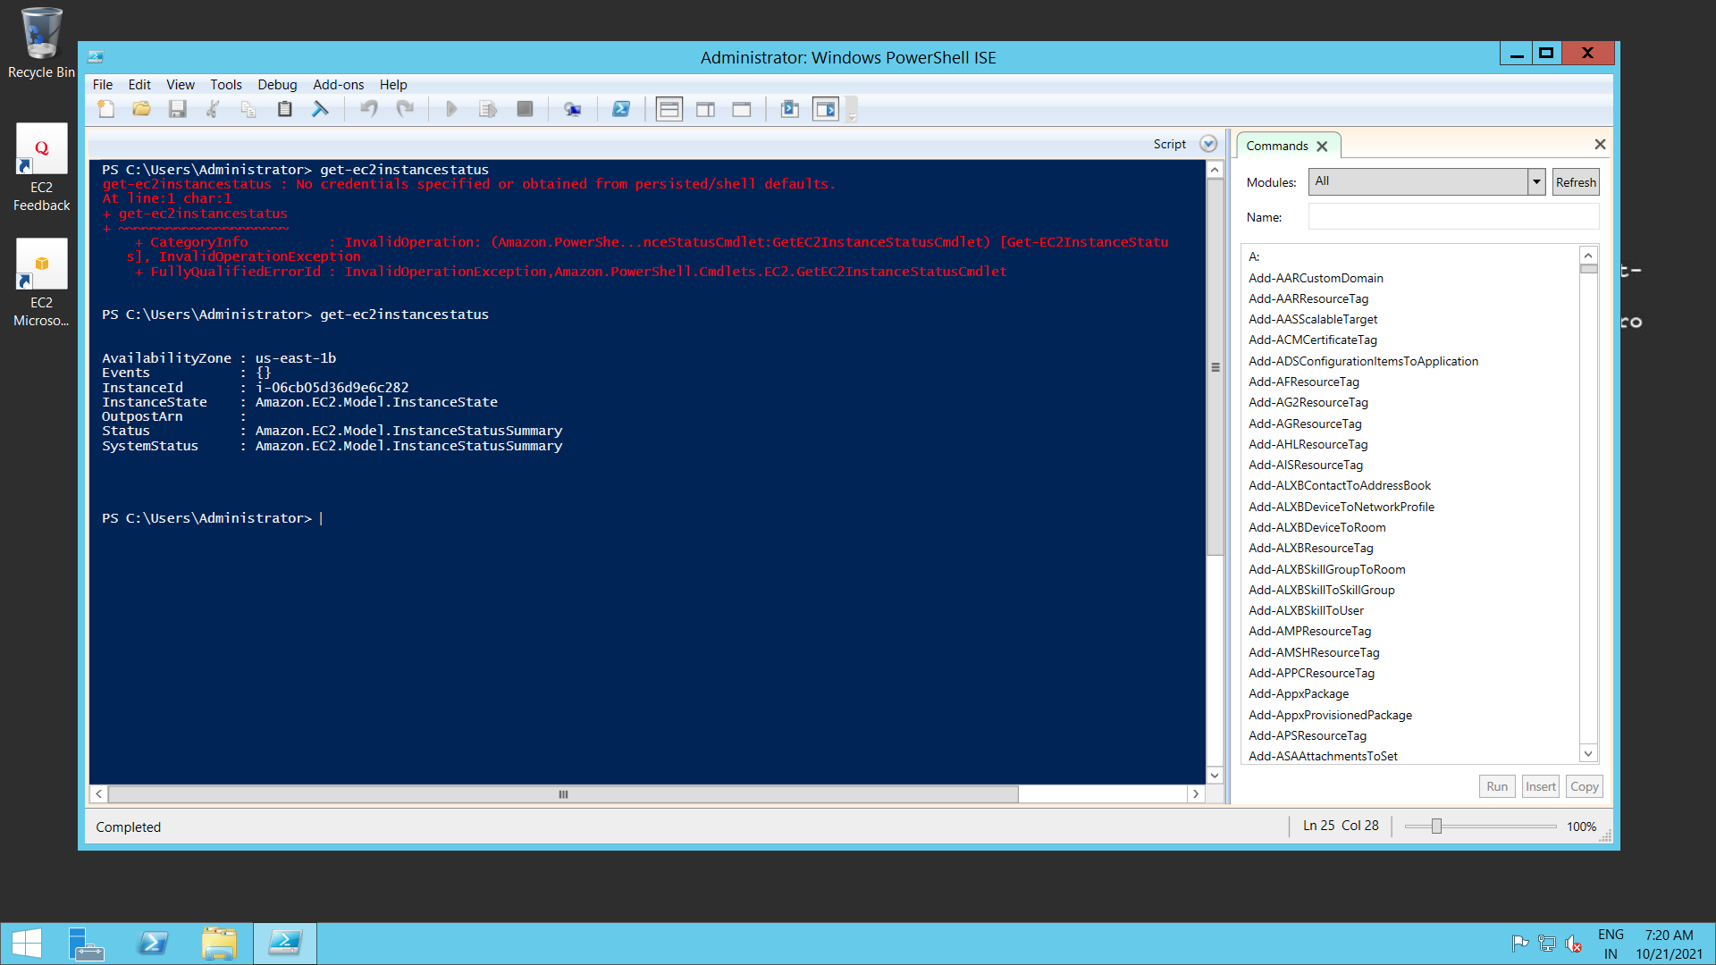

To get a list of EC2 instance IDs🡪 (Get-EC2Instance).Instances | Select-Object InstanceID

Retrieve additional information about the instance🡪 (Get-EC2Instance -InstanceID instance ID).Instances

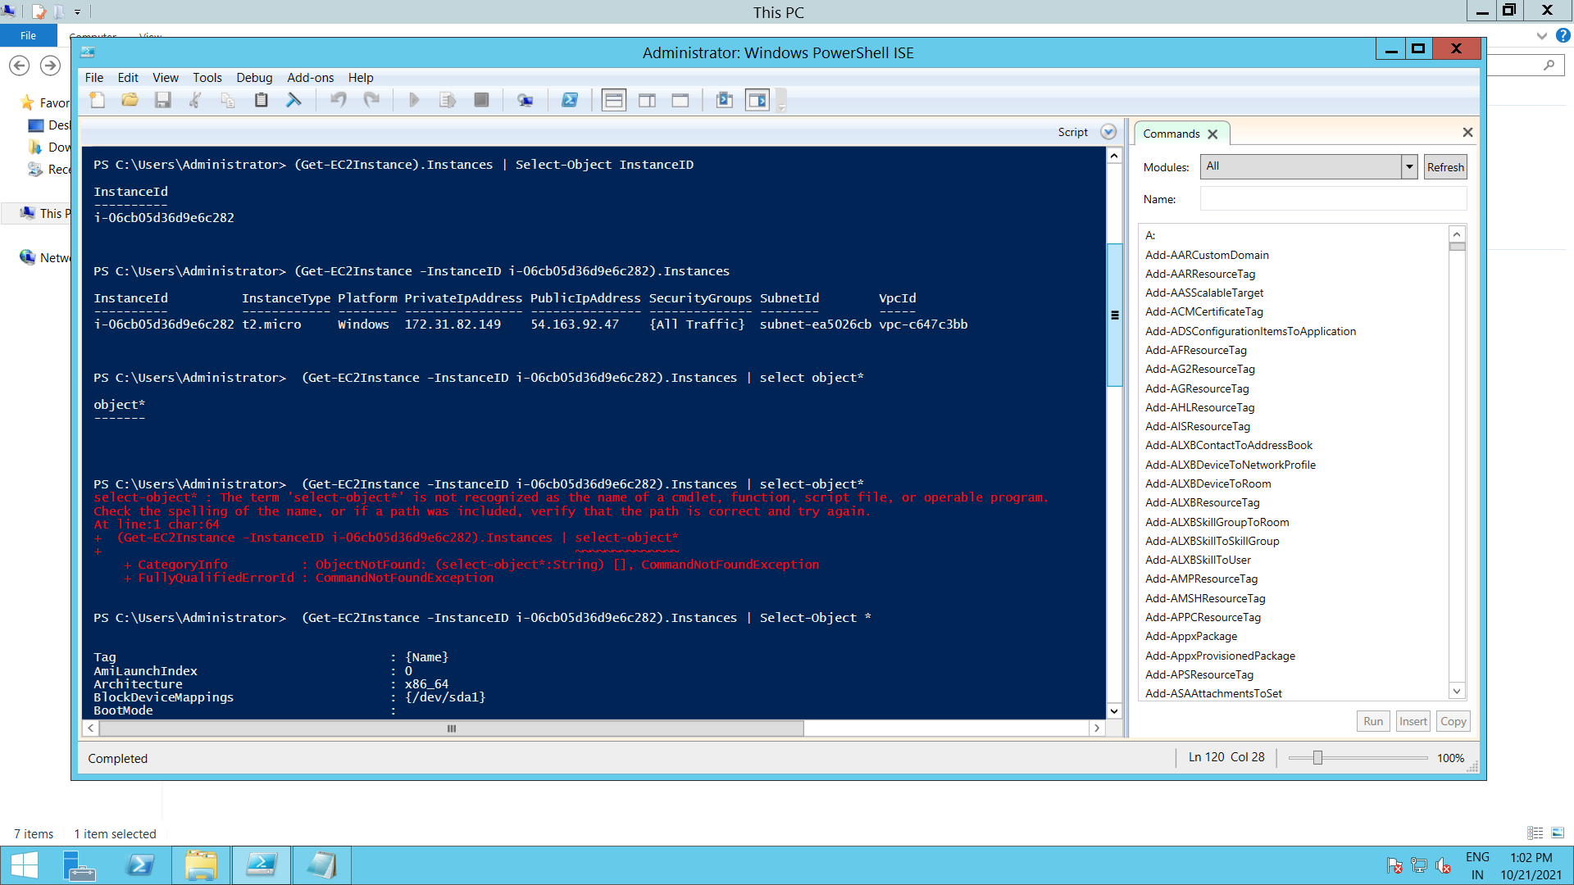

Retrieve all of the available attributes🡪 (Get-EC2Instance -InstanceID instance ID).Instances | select-object *

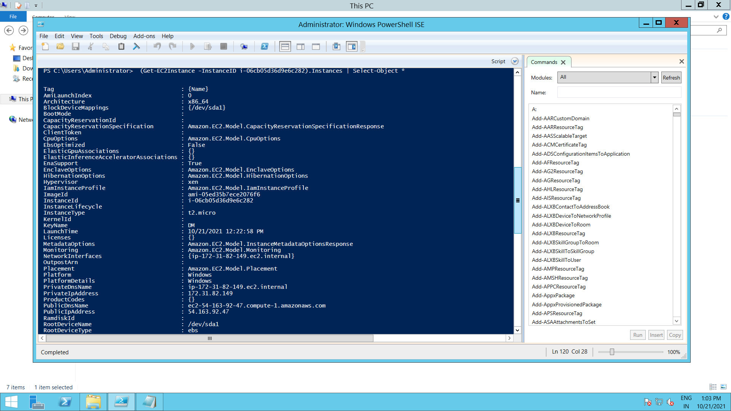

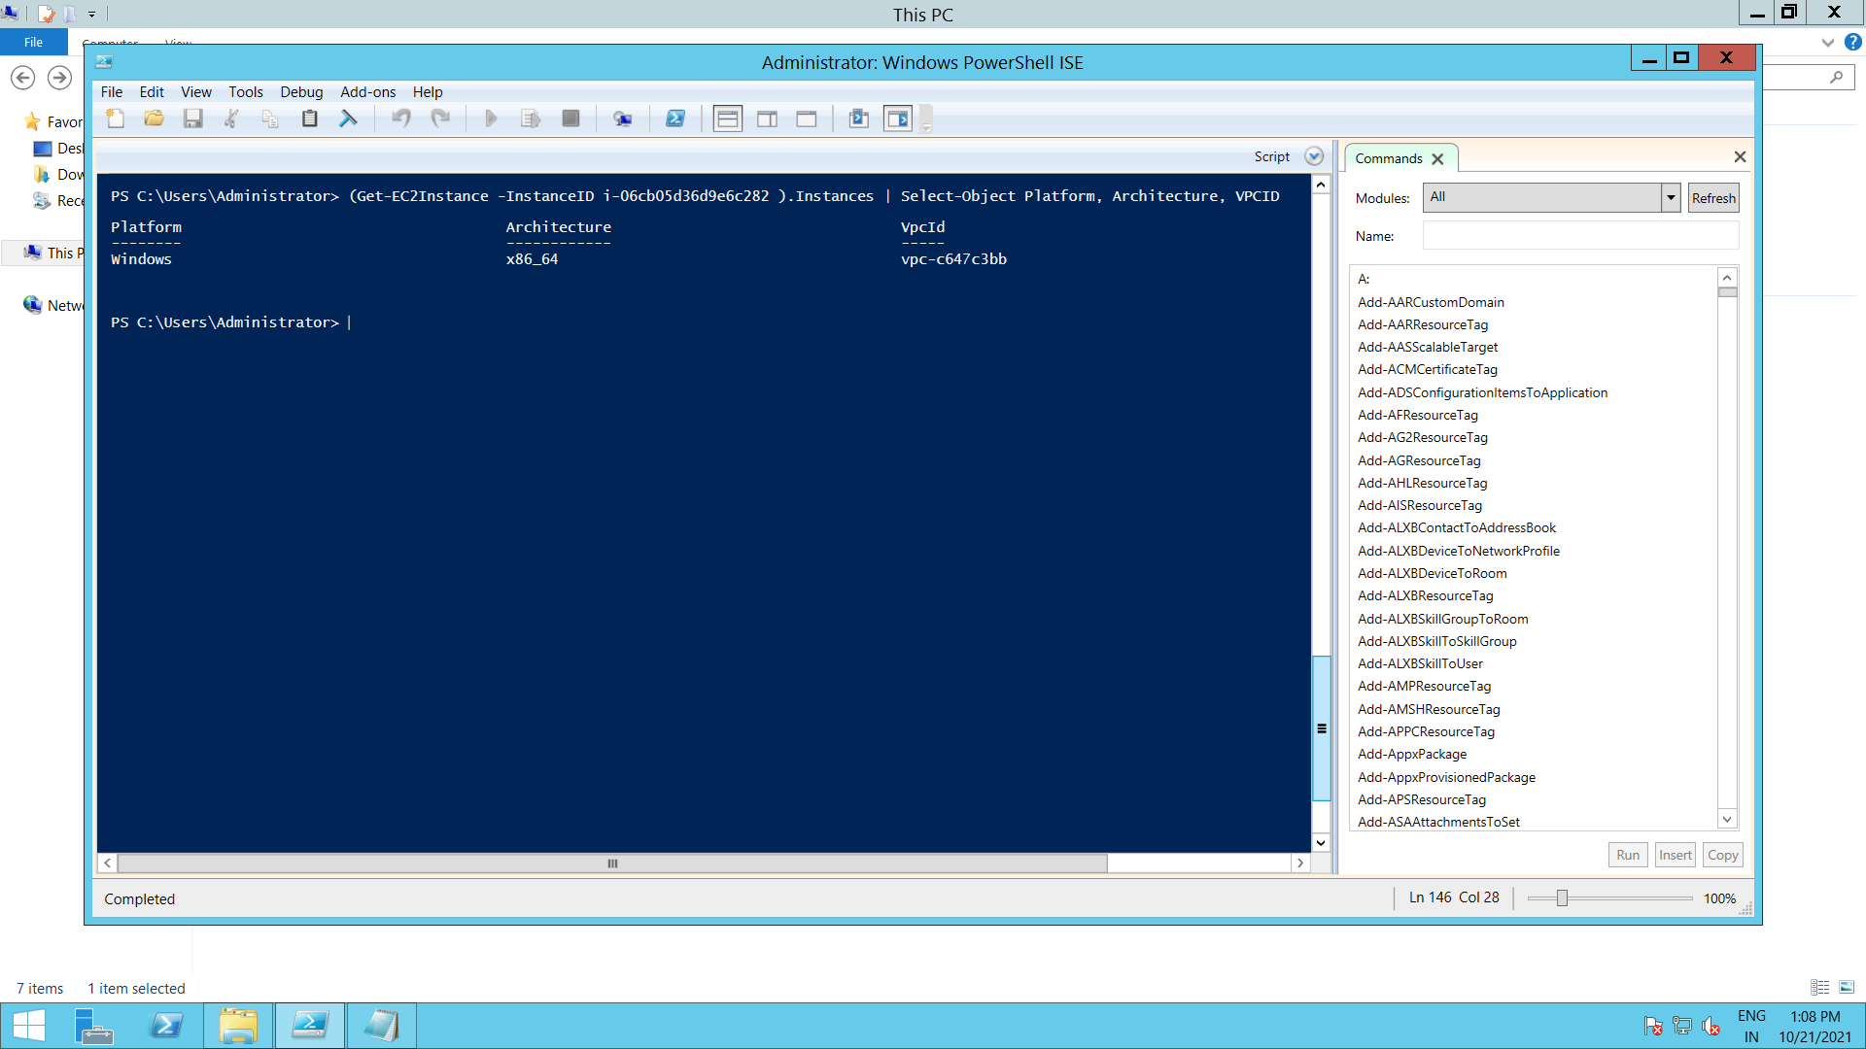

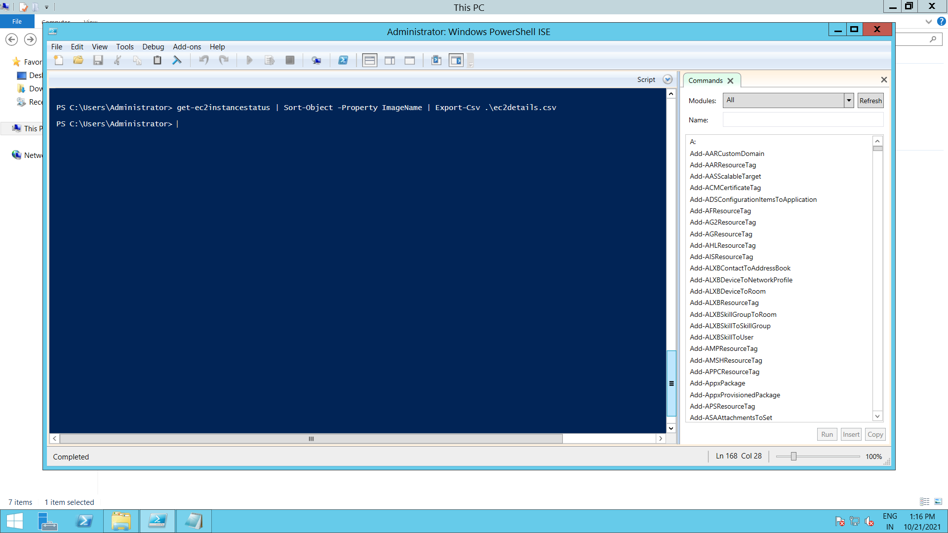

Final Output:

